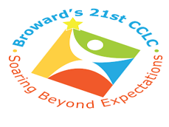

**North Fork Elementary**

**“Celebrating Hispanic Culture”**

**Student Advisory Council (SAC) Agenda**

**October 5, 2021 at 3:15 p.m.**



* **Introductions**
* **School Mission and Vision**
* **Principal’s Report**
* **SAC Bylaws**
* **School Improvement Plan**
* **Stakeholders suggestions/input**
* **21st Century CCLC “Student Highlights”**
* **Student Exceptional Education (Ms. Phillips)**
* **School Accountability Funds**